

Microprocessor and Interfacing Lab

(CSC508)

# Practical Lab File

Submitted To: Submitted By

## Dr. Rajiv Verma Nitesh Shakya

Roll No.- 12111023

## Branch: CSE Semester: 5

Session: 2021-25

|  |  |  |
| --- | --- | --- |
| **Practical o.** | **Topic** | **Page Number** |
| 1. | Addition of two 8 bit numbers | 5 |
| 2. | Subtraction of two 8 bit numbers | 6 |
| 3. | Addition with a carry of two 8 bit numbers | 7 |
| 4. | Subtraction with a borrow of two 8 bit numbers | 8 |
| 5. | Multiplication of two 8 bit numbers using repeated addition | 9 |
| 6. | Multiplication of two 8 bit numbers using bit rotation | 10 |
| 7. | Division of two 8 bit numbers using repeated addition | 11 |
| 8. | Division of two 8 bit numbers using bit rotation | 12 |

Practical 1: - Write a program for addition of two 8 bit numbers

CODE:

MVI A,01H

MVI B,05H

ADD B

STA 0000H

HLT

OUTPUT:

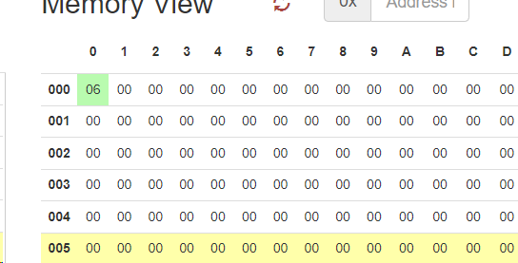

Practical 2: - Write a program for subtraction of two 8 bit numbers

CODE:

MVI A,11H

MVI B,05H

SUB B

STA 0000H

HLT

OUTPUT:

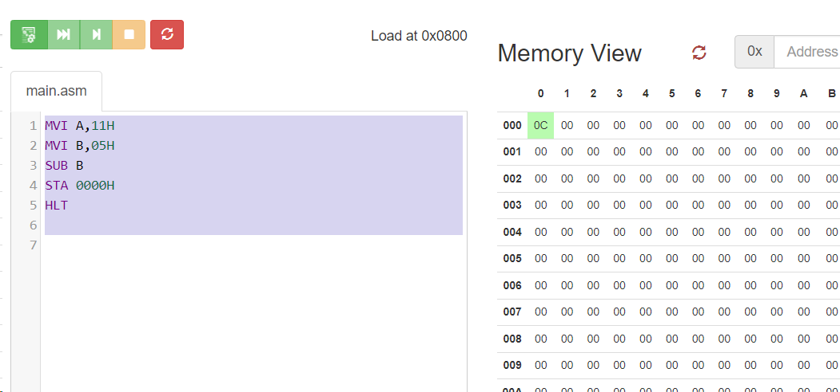

Practical 3: - Write a program for addition with a carry of two 8 bit numbers

CODE:

MVI A, 00H

MVI B,23H

MVI C,98H

MVI D,45H

MVI E, 22H

MOV A,C

ADD E

MOV C,A

STA 0061H

MOV A,B

ADC D

STA 0060H

hlt

OUTPUT:

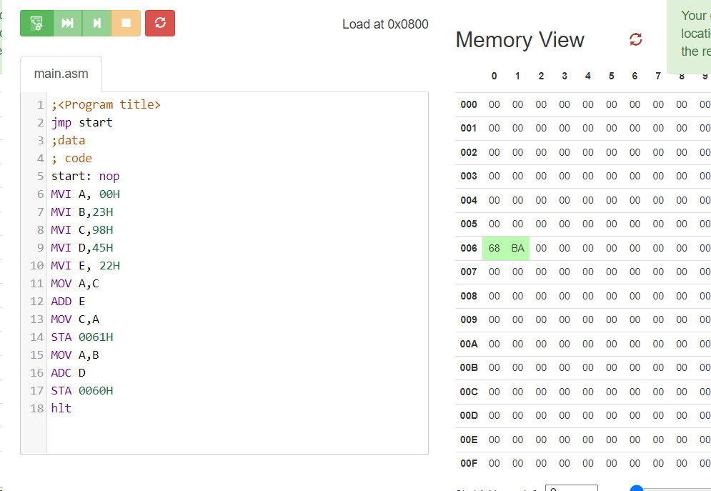

Practical 4: - Write a program for subtraction of two 8 bit numbers with borrow.

CODE:

MVI A, 8DH

MVI B, 7DH

MOV C, A

SUB B

JC SUBTRACT

SUBTRACT: STA RESULT

RESULT: DB 00H

HLT;

OUTPUT:

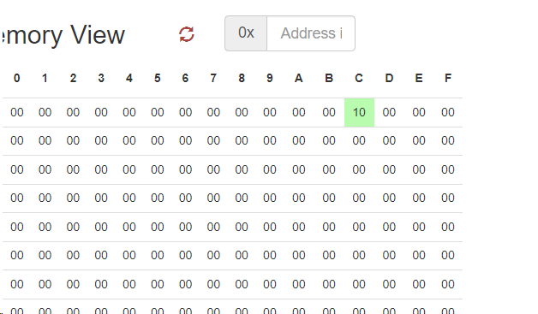

Practical 5: - Write a program for multiplication of two 8 bit numbers using repeated addition.

CODE:

MVI b,02h

MVI c,04h

MVI a, 00h

MVI d,00h

loop: add b

jnc skip

inr d

skip: dcr c

jnz loop

mov b,d

mov c,a

mov a,c

sta 0000h

hlt

OUTPUT:

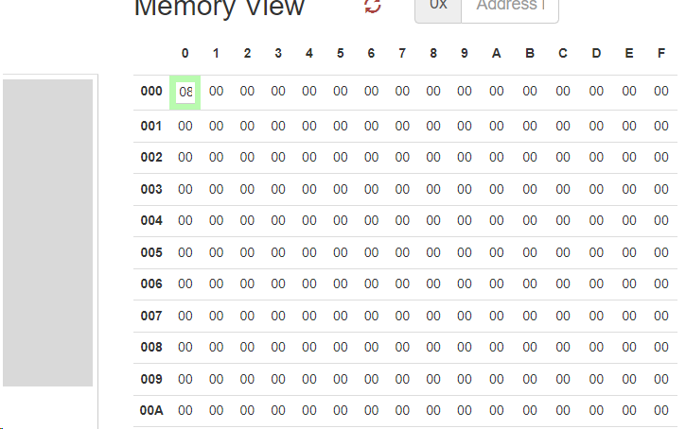

Practical 6: - Write a program for multiplication of two 8 bit numbers using bit rotation method

CODE:

MVI D,06H

MVI A,05H

LXI H,0000H

LOOP:   RRC

        JNC SKIP

        DAD D

SKIP:   XCHG

        DAD H

        XCHG

        DCR C

        JNZ LOOP

        HLT

OUTPUT:

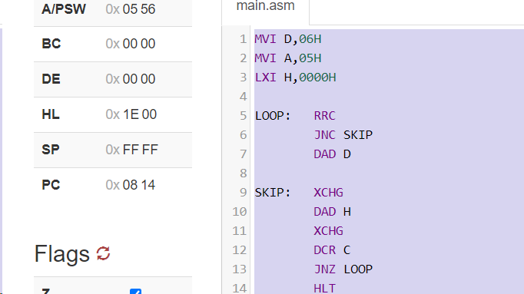

Practical 7: - Write a program for division of two 8 bit numbers by repeated addition method.

CODE:

MVI A, 27H

MVI B, 05H

MVI C, 00H

MVI D, 00H

LOOP: SUB B

      JC DONE

INR C

JMP LOOP

DONE: MOV E, A

HLT

OUTPUT:

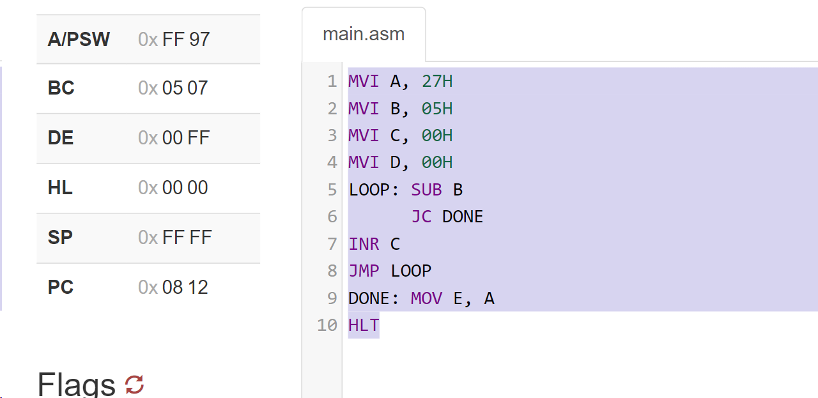

Practical 8: - Write a program for division of two 8 bit numbers using by bit rotation method.

CODE:

    MVI E,00H;

    LHLD 0008H;

    LDA 0007H;

    MOV B,A;

    MVI C,08H;

NEXT:DAD H;

    MOV A,E;

    RLC

    MOV E,A;

    MOV A,H;

    SUB B;

    JC SKIP;

    MOV H,A;

    INR E;

SKIP:DCR C;

    JNZ NEXT;

    MOV A,E;

    STA 0033H;

    MOV A,H;

    STA 0034H;

    HLT;

OUTPUT:

